**Unmanned Aircraft Policy**

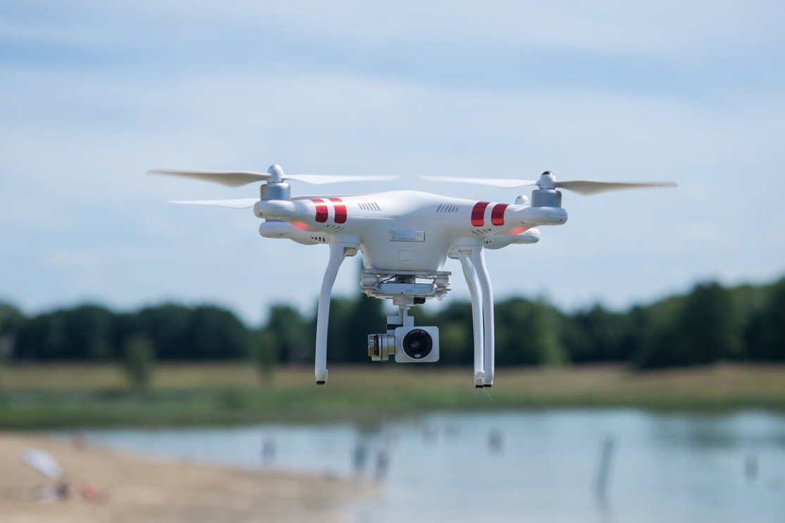

# Contents

# Purpose

To provide guidance on where, and under what conditions the public are allowed to fly unmanned aircraft over land controlled by Hastings District Council.

# Definitions

***Aircraft:*** has the same meaning as in the Civil Aviation Rule and includes an aeroplane, balloon, glider, hang glider, helicopter or microlight

***Remotely Piloted Aircraft (RPA):*** any remotely piloted aircraft and includes an unmanned or free flight aircraft and model aircraft under line control.

***Unmanned Aircraft:*** includes Unmanned Aerial Vehicles (UAV), Unmanned Aerial Systems (UAS), Remotely Piloted Aircraft (RPA) and drones.

# Background

The Civil Aviation Authority (CAA) regulates civil aviation in New Zealand, and sets the rules around the use of unmanned aircraft. CAA Rules Part 101 and 102 came into effect on 1 August 2015 and relate specifically to unmanned aircraft and places restrictions around the use of unmanned aircraft. All unmanned aircraft operations, regardless of size, weight, or performance of the aircraft are required to operate in compliance with these rules.

CAA Rule Part 101 permits operators of unmanned aircraft to fly without needing to obtain the consent of the CAA provided they operated strictly within the prescribed limits of the CAA Rule Part 101. The rule requires a person operating an unmanned aircraft to gain consent from the property owner or occupier of the area(s) over which they intend to operate.

CAA Rule Part 102 is designed for higher-risk operations. If an operator cannot comply with Part 101 this is a good signal that the operation may be higher risk and require certification from the CAA under Part 102. Operators will need to contact the CAA directly for this certification.

# Policy Statement

Hastings District Council will grant consent for the flying of unmanned aircraft above land controlled by Council subject to the Hastings District Council’s conditions, and provided the unmanned aircraft operator adheres strictly to the CAA operating rules. Primarily:

* CAA Rule Part 101 requires operators to get consent from any person they may fly over (this must be obtained in writing); and
* The CAA rules have an overriding requirement not to operate in a manner that is hazardous to people or property.

Hastings District Council is not responsible for setting, monitoring or enforcing the CAA rules. If you have concerns that:

* CAA rules are being breached please contact the CAA on [isi@caa.govt.nz](mailto:isi@caa.govt.nz) or phone 0508 4SAFETY (0508 4723389).
* a drone flies above your property without permission or you feel your privacy has been breached, you can make a complaint to the Privacy Commissioner.
* If there is an imminent threat to people or property, please contact the Police.
* If a drone operator has breached the Unmanned Aircraft and Drone Policy phone 06 871 5000.

Nothing in the above applies to a person operating an unmanned craft for the purposes of a civil defence, accident or other emergency service response, at the direction of the person in charge of that response.

# Conditions of Unmanned Aircraft Operations

Hastings District Council grants consent for the flying of unmanned aircraft above land controlled by Council provided unmanned aircraft operators:

* are courteous and considerate of other users of the property; and
* do not fly over other people or adjoining private property without their consent (complying with the Office of the Privacy Commissioner guidance on preserving peoples’ personal privacy); and
* do not film anybody with an on-board camera without their express permission; and
* do not operate within 50 metres of any playground, paddling pool or swimming pool; and
* do not fly over or within 50 metres of livestock and horses (ridden or unridden) on parks, sensitive wildlife habitats such as wetlands or nesting or roosting birds; and
* do not operate over Council cemeteries; and
* do not operate directly over occupied camp sites; and
* do not operate over a sports field if it is in use by others; and
* do not operate within 100 metres of any event where there is a road closure for that event; and
* do not fly closer than ten metres to the boundary of Council controlled land and private property without the permission of that land owner/occupier; and
* avoid distraction to the road user and to ensure the safety of the operator. It is prohibited to fly over roads of any class unless a Traffic Management Plan (TMP) has been submitted in accordance with the Code of Practice for Temporary Traffic Management (CoPTTM). The appropriate TMP must be applied for and approved prior to the operation. Traffic Management to be supplied by an approved traffic management provider only; and
* those certified to Part 102 **ONLY** can fly in road reserve.
* apply to the Council for permission for any events, via the event organiser;
* has a TMP Plan applied for and e-mailed to one of the names as listed below;
* cease operation if requested by Council staff.

# Applying for Consent

Any person seeking to operate unmanned aircraft outside these conditions must seek consent by completing the application form where a consent approval must be obtained prior to activities.

Apply by contacting the following officer to gain consent and to have the relevant conditions set and verified with the appropriate form being signed off.

Lynn Burden - Transportation Officer

[lynnb@hdc.govt.nz](mailto:lynnb@hdc.govt.nz)

# CAA Rule Part 101

Operation of unmanned aircraft in accordance with the CAA Rule Part 101 is subject to the following restrictions. There are 12 key things that are required under Part 101. You must:

1. not operate an aircraft that is more than 25kg and always ensure that it is safe to operate; and
2. at all times, take all practicable steps to minimise hazards to persons, property and other aircraft (i.e. don’t do anything hazardous); and
3. fly only in daylight; and
4. give way to all crewed aircraft; and
5. be able to see the aircraft with your own eyes (e.g. not through binoculars, a monitor, or smartphone), to ensure separation from other aircraft (or use an observer to do this in certain cases); and
6. not fly your aircraft higher than 120 metres (400 feet) above ground level (unless certain conditions are met); and
7. have knowledge of airspace restrictions that apply in the area you want to operate; and
8. not fly closer than four kilometres of any aerodrome (unless certain conditions are met); and
9. when flying in controlled airspace, obtain an air traffic control clearance issued by Airways Corporation of New Zealand; and
10. not fly in special-use airspace without permission of the administering authority of the area (e.g. restricted or military operating areas); and
11. have consent from anyone you want to fly above, and
12. have consent of the property owner or person in charge of the area you want to fly above.

This list should not substitute a full reading of CAA Rule Part 101. You should conduct a thorough assessment of your operation and ensure you understand the Civil Aviation Rules that apply to your operation, before deciding whether to operate under Part 101 and 102.

Some exceptions may apply, but generally if you cannot meet any of these requirements this is a good signal that your operation will need to be certified under CAA Rule Part 102.

# Further Information

Unmanned aircraft are not permitted to fly within a 4km radius of the Hawke’s Bay Airport and the Hastings Aerodrome. Unmanned aircraft are not permitted to fly in Low Fly Zones. See Appendix Map showing:

* Control zone managed by Air Traffic Control at Hawke’s Bay Airport;
* 4km radius around Hawke’s Bay Airport Hastings Fallen Soldier Memorial Hospital and the Hastings Aerodrome;
* Restricted Areas at Cape Kidnappers where permission must be granted by the administrating authority; and
* Low Flying Zones on Ngaruroro River and upper stem of Ahuriri Estuary.

All Council managed parks within the Hastings District fall within these no-fly zones except those zones are listed below:

Hastings / Flaxmere - Roys Hill

Havelock North - Romanes Drive / Guthrie Park / Tainui Reserve

Coastal - Te Awanga Reserve

Te Mata Peak access and permissions are not managed by the Hastings District Council.

If you wish to undertake an activity on Te Mata Peak please contact Emma Buttle at:

[info@tematapark.co.nz](mailto:info@tematapark.co.nz)

The Civil Aviation Authority’s website provides full details of Rules Part 101 and 102 and further advice for operators of unmanned aircraft. Visit the website at: <https://www.caa.govt.nz/rpas/index.html>.

Also see the Airshare website for further information on the safe operation of unmanned aircraft. <https://www.airshare.co.nz/>.

The following website provides practical answers to your drone questions:

<https://www.flyyourdrone.nz/>

# Appendix

**KEY TO THE COLOUR CODING ON THE MAP**

|  |  |  |  |
| --- | --- | --- | --- |
|  | The **red transparent areas** are control zones. Control zones are managed by Air Traffic Control and extend down to ground level. |  | The **green areas** are Military Operating Areas. Permission from the Administering Authority is required. |
|  | The **blue circled areas** indicate a 4km radius around aerodromes. |  | The **bright blue areas** are Restricted Areas. Permission from the Administering Authority is required. |
|  | The **orange areas** are Low Flying Zones. UAVs are not permitted to fly in any Low Flying Zones. |  |  |

## If calling ask for Lynn Burden

## lynnb@hdc.govt.nz

File Ref: Record Number

Application Date:……………………

**CONSENT APPLICATION FOR APPROVAL AND OPERATION OF UNMANNED AIRCRAFT**

**(RPAS / DRONE)**

**Location: Date and Time of Flight:**

*(Please circle and add details as necessary)*

**Road Reserve Park Public Place**

*Address Park Name Area*

Name and Details of Certified Part 102 Operator requesting Consent to operate unmanned aircraft.

Name: Cert 102 / License No:

Address:

Tel No:

E-mail Address:

**Only Part 102 Certified individuals are certified to operate an unmanned aircraft within the Hastings District Council (HDC). A copy of the certificate must be supplied with the application**

It is necessary for a Traffic Management Plan (TMP) to be submitted where the flight is intended to be over any road reserve.

If TMP is required, it **MUST** be appended to this application. The TMP must be emailed to Lynn Burden [lynnb@hdc.govt.nz](mailto:lynnb@hdc.govt.nz) for approval so that it can be given a TMP reference number.

TMP Reference No: Date approved:

**HDC Staff to complete below:**

In accordance with the **HDC Policy and Procedures Manual**, permission is **GRANTED / NOT GRANTED** to:………………………………………. to operate an unmanned aircraft within the location as stated above.

These Conditions and Recommendations are only valid if permission has been granted:

1. Operator to supply an up to date copy of their certification (Part 102).
2. Operator to provide their operating procedure. (H&S etc).
3. Consideration must be given to people’s privacy in adjacent properties.
4. Avoid flying over private properties, but where unavoidable, all property owners MUST be notified.
5. Consideration must be given with regard to the annoyance at Parks and Public Places.
6. Avoid distraction, it is **PROHIBITED** to fly over roads of any class unless a Traffic Management Plan (TMP) has been submitted. Traffic Management to be supplied by an approved traffic management provider only.

The Operator must only fly in the area as stated above and must comply with the Conditions as listed above. The Operator must provide evidence as necessary / requested.

I hereby agree to operate the unmanned aircraft as per this Consent Application.

Unmanned Aircraft Type: Drone RPA UAS UAV

Operators Name:

Signature:

Date:

**Recommended by:** **TRANSPORTATION OFFICER**

Signature:

Date: